**Women in National Parliaments: A Comparative Study of UN and MMDT Results**

|  |  |  |  |
| --- | --- | --- | --- |
| **No** | **UN Findings** | **MMDT Findings** | **Remark** |
| 1 | Only 26.9% of parliamentarians in single or lower houses are women, up from 11% in 1995. | Average women representation is 24.3% based on data from 2019-2025. | UN did not clarify whether 26.9% is an average value or not. |
| 2 | Only six countries have 50% or more women in parliament: Rwanda (61%), Cuba (56%), Nicaragua (54%), Andorra (50%), Mexico (50%), New Zealand (50%), and UAE (50%). | The average women representation per region for the top 5 countries ranges from 10.5% to 61.5%. Above 50% countries: Rwanda (61%) and Cuba (54%). | UN provides a static list, while MMDT includes regional averages. |
| 3 | 22 countries have reached or surpassed 40%, mostly in Europe, Africa, and Latin America. | 17 out of 194 countries have above 40% women parliamentarians, mostly from the Americas, Europe, and Sub-Saharan Africa. | UN lists regions while MMDT gives total count. |
| 4 | 21 states have less than 10% women in parliament, including two lower chambers with no women. | Bottom 5 countries have women representation ranging from 0.1% to 18%, mostly from the Pacific, Asia, and middle-east-and-north-africa. | UN highlights total affected states, MMDT focuses on lowest-performing regions. |
| 5 | At the current rate, gender parity in legislative bodies will not be reached before 2063. | No formal projection for 2030, but data shows slow increases over recent years. | MMDT lacks long-term projection analysis. |
| 6 | Regional variations: Latin America (36%), Europe & Northern America (33%), Sub-Saharan Africa (27%), Eastern/Southeastern Asia (23%), Oceania (20%), Central/Southern Asia & Western Asia (18%). | South America, North America, Western Europe, Australia & New Zealand, and Nordic countries have 30%-44% women representation. Southeast Asia: 21.8%. | MMDT data is broken down into more specific subregions. |
| 7 | Women in local government: Central/Southern Asia (41%), Europe/Northern America (37%), Oceania (32%), Eastern/Southeastern Asia (31%), Latin America/Caribbean (27%), Sub-Saharan Africa (25%), Western Asia and Northern Africa (20%). | **Highest Representation**: Nordic Countries, Australia & New Zealand, Western Europe (40-50%).  **Moderate**: Southern Africa, South America, Caribbean (30-40%).  **Low**: Central Asia, Middle East, East Asia, Pacific Islands (<20%). | Both analyses agree on regional disparities in local representation. |
| 8 | No direct analysis of how population size and structural factors influence female representation in parliament | * Countries with low female representation (below 30%) and small populations (under 400,000) often face cultural barriers or lack gender quotas. * Countries with moderate female representation (15-30%) and large populations (over 1 million) typically experience systemic gender equality challenges. * Countries with high female representation (30-60%) vary in population size but tend to have strong gender policies and quotas supporting women in politics.   Figure 1.1 shows the clustering of countries based on women in parliament by MMDT. | The analysis groups countries based on their level of female representation in parliament and population size. It highlights common patterns, such as cultural and policy influences, that impact women's participation in politics. |

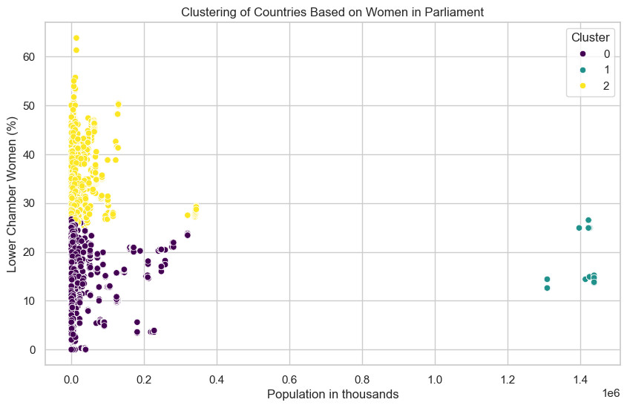

**Fig 1.1: Clustering of Countries Based on Women in Parliament by MMDT**

**Women in Executive Government Positions: A Comparative Study of UN and MMDT Results**

|  |  |  |  |
| --- | --- | --- | --- |
| **No** | **UN Findings** | **MMDT Findings** | **Remark** |
| 1 | As of June 2024, 27 countries have 28 women as Heads of State/Government. Gender equality at this level is expected to take 130 years. | No analysis on government data. | MMDT does not cover executive positions. |
| 2 | 23.3% of Cabinet members leading ministries are women. 15 countries have over 50% women in Cabinet. | No analysis on government data. | MMDT lacks ministerial representation data. |
| 3 | Most common portfolios held by women: Gender equality, family affairs, social inclusion, social protection, and minority affairs. | Parliament dataset themes show higher female representation in defense, gender equality, and women's caucus topics. | Gender equality remains a common theme in both datasets. |

**Summary by UN**

The Beijing Declaration and Platform for Action aim for balanced political participation and power-sharing between women and men in decision-making. While gender parity has not been fully achieved, gender quotas have significantly improved women's representation, with a higher percentage of women in parliaments and local governments in countries with quotas. Research shows that women’s leadership in political decision-making positively impacts outcomes, such as more drinking water projects in women-led councils in India and better childcare coverage in Norway. Women also lead efforts for gender equality by collaborating across party lines and championing policies like gender-based violence elimination, parental leave, and electoral reform.

**Summary by MMDT Team**

This analysis underscores the need for continued policy efforts, institutional support, and legislative reforms to drive a more consistent and substantial increase in women's representation in parliament across different governance models.

While no single factor solely determines women’s representation, a combination of gender policies, political systems, human rights, and equality measures plays a crucial role. Additionally, cultural, economic, and broader policy-related factors may have an even greater impact than political systems alone.

Despite progress, women's participation in parliament remains uneven. Institutional reforms, gender quotas, electoral policies, and political structures significantly influence inclusivity. Future efforts should prioritize policy-driven interventions to ensure sustained and equitable representation worldwide.

**Conclusion After Comparison**

After comparing the findings from the UN and our team’s analysis, we observe several key similarities and insights:

1. **Similar Trends in Women’s Representation**: Both the UN and our team’s analysis highlight the overall low representation of women in parliaments globally, with notable exceptions in specific countries. For instance, both reports identify countries such as Rwanda and Cuba as leading examples of high women’s representation, while also acknowledging that there are still many countries with less than 10% women parliamentarians.
2. **Regional Variations**: Both analyses underscore the regional disparities in women’s political representation. While the UN emphasizes the differences in gender representation across various regions like Latin America, Europe, and Africa, our team’s findings similarly point out the wide variability in representation, particularly in regions like Southeast Asia, the Middle East, and Pacific Islands.
3. **Impact of Gender Quotas and Policies**: Both analyses agree on the importance of gender quotas and policies to advance women’s participation in politics. Our team’s insights align with the UN's findings that institutional reforms, political systems, and gender equality measures are critical to improving women's representation in legislative bodies.
4. **Need for Continued Efforts**: Both reports recognize that progress towards gender parity in politics has been slow and uneven, with no clear path to gender parity in legislative bodies before 2063 according to the UN. Our team’s analysis similarly highlights the need for continued policy efforts, institutional support, and legislative reforms to drive substantial improvements.